Problem 1: Principles of Cam Design (12 pts)

a) (2 pts) Describe the Fundamental Law of Cam Design in your own words.

b) (2 pts) Why is a discontinuity in velocity undesirable? What about a discontinuity in acceleration?

c) (2 pts) List 1 advantages and 1 disadvantage of a cam-follower compared to a crank-slider.

d) (6 pts) Name the below shown cam-followers in terms of
i) Type of cam: radial vs. axial,
ii) Type of follower motion: rotating vs. translating,
iii) Type of joint closure: force-closed vs. form-closed

 | Type of cam | Type of follower motion | Type of joint closure
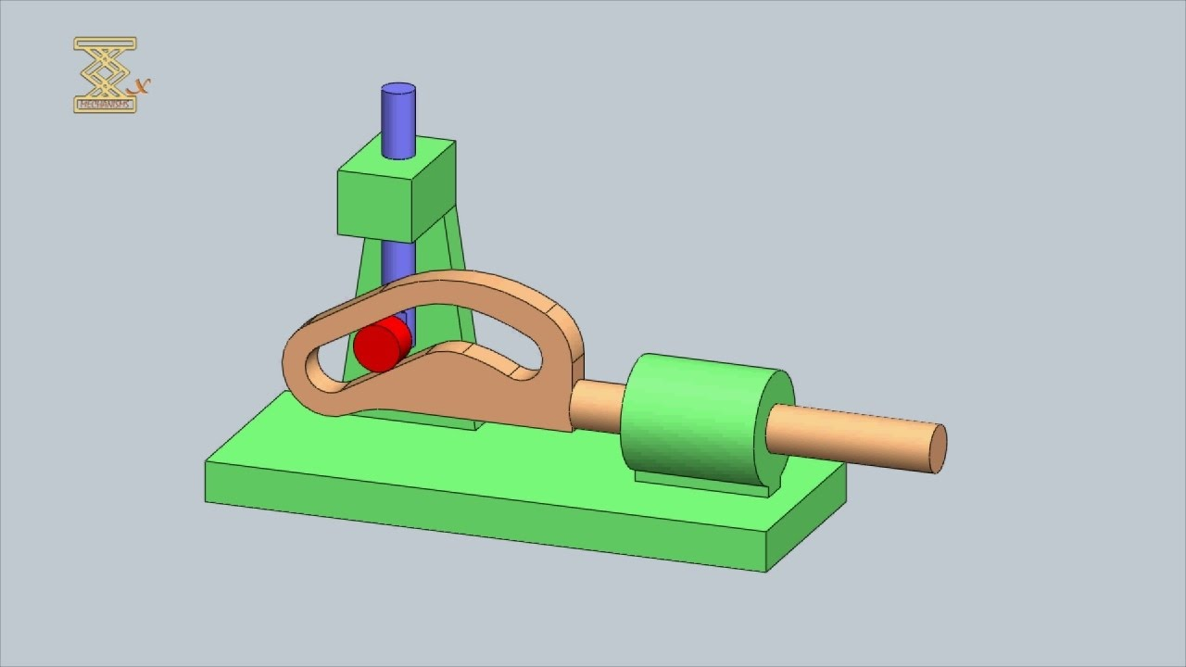
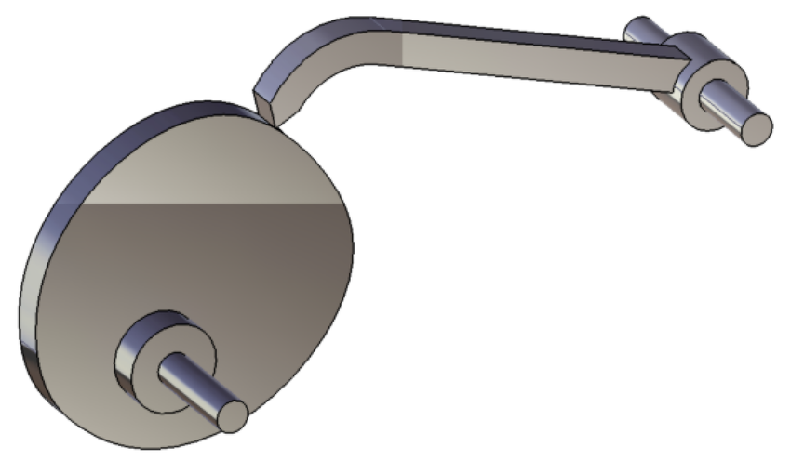

Problem 2: Motion design (13 pts)
Upon graduation, you have been hired by Intel to help them setup a fabrication facility for their newest line of chips. Your task is to design a chip delivery system for their testing room. A tray attached to a follower will: (a) wait under a robotic arm while a new chip is being placed, (b) move away from the arm and travel across the room, (c) wait at the other end of the room a while another arm picks up the chip for further evaluation, and (d) return to the initial machine where another chip will be deposited. (Do not be concerned about the mechanisms used to place or pick up the chip.) This motion of the device will be driven by a cam-follower design.
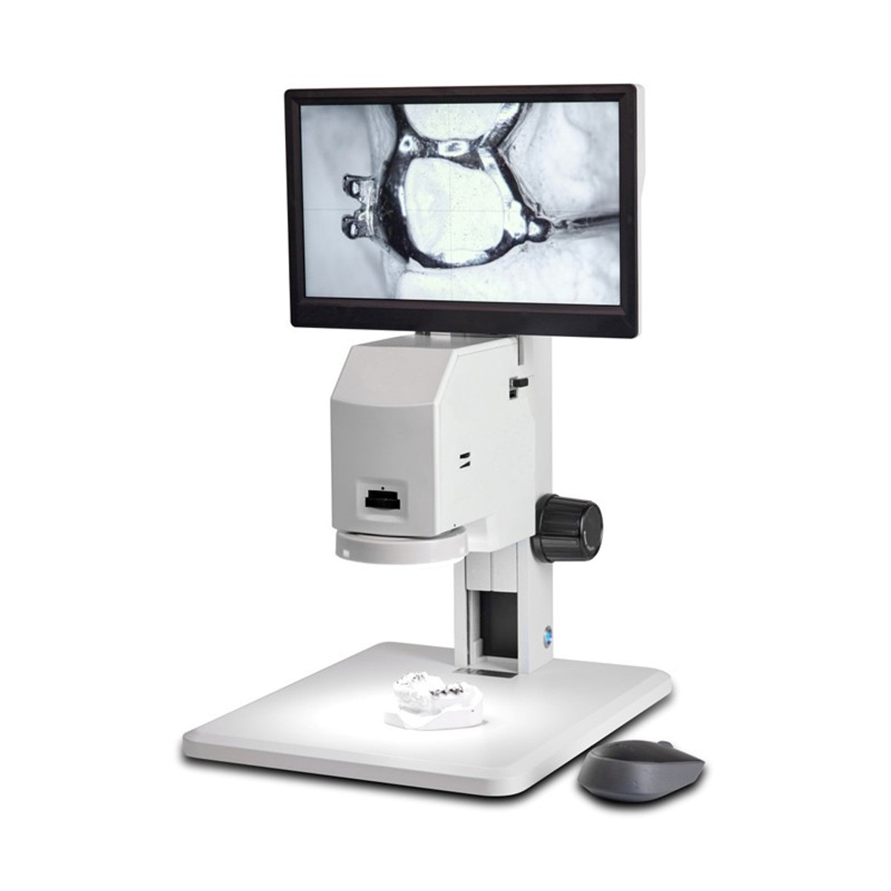
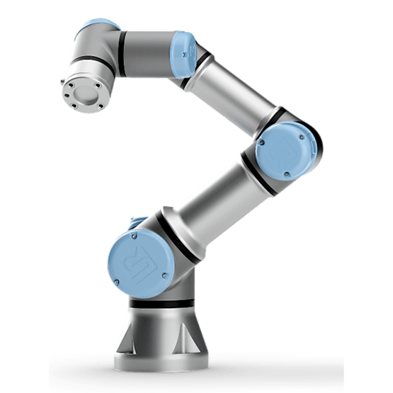


8”
Cam goes here
The chip must wait under the first arm for 1s. It then travels (rise) to the other arm a distance of 80mm in 4s. It remains in this location for 3s and then returns to the initial location in 2s. The motor driving the cam has a constant velocity of ω = 30°/s.

a) (1 pt) What type of cam-follower is appropriate here, (a) Oscillating, (b) Translating? Create a plot of displacement (s) as a function of time (t).

b) (2pts)The risk of damaging the chip can be minimized by having the smoothest jerk profile. During the rise segment of the motion program, indicate which motion function you would choose based on this information, and explain your selection.

c) (4 pts)Using the function you chose from part b, write the expression for the time-dependent displacement function s(t) for the follower motion during this segment of the motion program. Your final expression for s(t) should contain only s, t, and numerical constants that are relevant to this problem. (You do not need to multiply any numerical values.)

d) (6 pts) Write the expression of the velocity and acceleration, and explain how to find the extremum values.

Select one of the following options:
- My answer was created by a Gen AI algorithm, and I have not modified it
- My answer was created by a Gen AI algorithm, and I have made some minor changes.
- My answer was created by a Gen AI algorithm, and I have made major changes.
- My answer was created solely by myself.
- If I used Gen AI, I used ___ (name of program).

